AWS Frontend Setup

Step 1 – Login using Git Bash

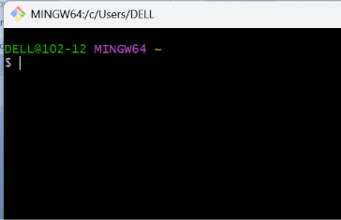

Step 2 – Login using ssh command using key
Step 3 – Go into Travel Memory.

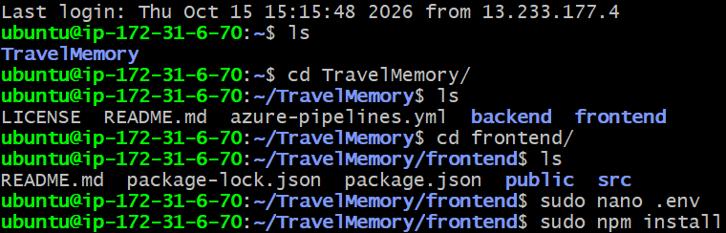

Step 4 – now go into frontend folder

Step 5 – Now create environment .

Step 6 – Now go to git hub site and look for FE part and paste the following command to .env file and change local host ip to public IP of your ec2 and save it.

REACT_APP_BACKEND_URL=http://localhost:3001

Step 7 – Now run sudo npm install.

Step 8 – Now run sudo npm start

Step 9 - Select frontend-master → same path → name it travelmemory-frontend-ami.

Step 10 - Launch a new instance from travelmemory-frontend-ami → frontend-2

